Creating a “one-off” prescription for Repeat Medication on EMIS Web
Did you know that it is possible to create a one-off prescription of a Repeat Medication whilst leaving the original details unchanged?
This process is easy to do and would be beneficial in scenarios where patients may need:
- A bridging prescription.
- A holiday quantity prescription.
- An alternative for a Repeat Medication that may be temporarily unavailable.
Using the one-off issue function creates a duplication of the Repeat Medication information which can be changed accordingly and will be added to the medication screen as an Acute supply whilst leaving the original Repeat Medication details on the Repeat screen unchanged.
This is how to create a one-off issue:
- Open the patient’s Medication screen.
- Select the Repeat Medication you would like to create a one-off issue for.
- On the top ribbon, click One-off issue: 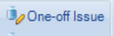
- If required, alter the medication in the One-off issue box. Note: if you are wanting to do a one-off prescription due to a Repeat Medication being temporarily unavailable, in the top left-hand corner of the Edit screen, select “Generic/Trade Switch”: 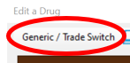 This will then give you all the other available options of that medication which you can use the arrows to browse through and select using “OK”:
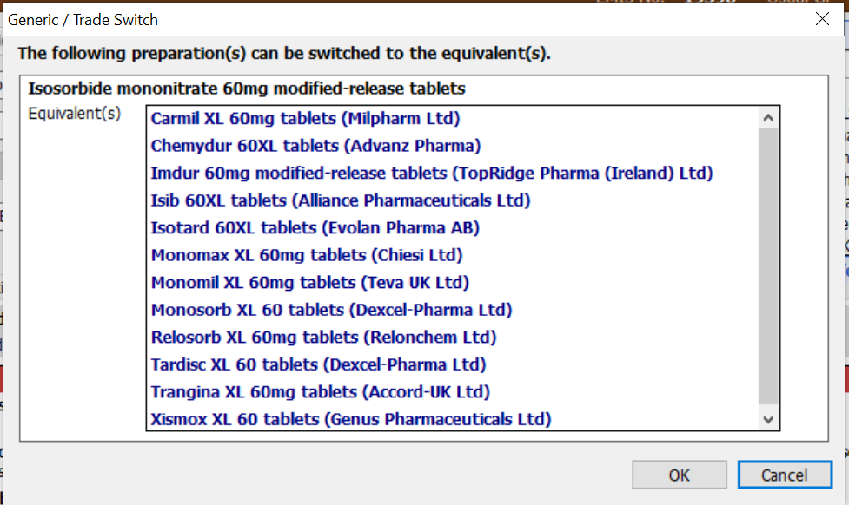
- Select Issue.
- Select Approve and Complete. (If a non-clinician is adding the one-off supply and would need to “Request Issue” at this point, please select “Cancel”. The one-off supply prescription details will sit in the Acute screen ready for requesting, “Request Issue” can then be used, and details of the changes can be added to the request for a signing clinician to see.)
- The issued medication will show under Acute in the Medication screen until the selected/default duration passes and EMIS will move it into the Past Drugs screen.
Important Note: One-off prescriptions are not documented as “one-off” in the Drug History, they can only be seen as an Acute supply, so it may be a consideration to document information of a one-off supply in the consultation screen with one of the following suggested codes if appropriate:
